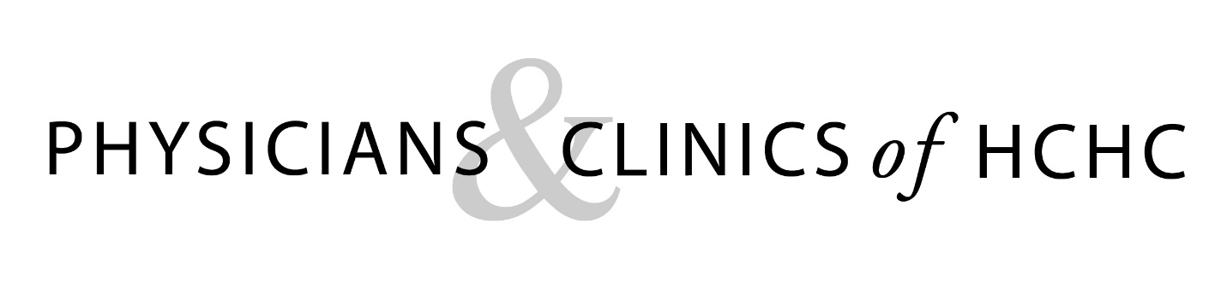
Women’s Health Services

At HCHC we are committed to meeting the healthcare needs of area women and young families with our Certified Nurse-Midwives, Kari Payne, ARNP, CNM, and Kendra Bonnesen, ARNP, CNM. We appreciate the opportunity to provide you and your growing family with high quality healthcare you can trust.

Q: What is a certified nurse-midwife (CNM)?
A: CNMs are board certified healthcare providers with advanced nursing degrees. CNMs focus on partnering with women to provide individualized care from puberty through the elderly years. In addition to specializing in pregnancy, labor, and birth, CNMs provide general healthcare to women, gynecologic services, family planning (birth control), breastfeeding help, and newborn care. For more information about CNMs, visit www.ourmomentoftruth.com.

Q: What services do the certified nurse-midwives offer to expectant parents?
A: Our CNMs give expectant parents local access to care during your pregnancy and after your baby is born. Your visits will occur at our Mt. Pleasant clinic, along with other services like ultrasounds and blood tests. After you give birth, you and your baby will be able to return to Mt. Pleasant to receive local care together, provided by Kari and Kendra. If you choose to breastfeed, the midwives and their staff will provide specialized lactation support and care.

Q: Where will I deliver my baby since HCHC does not have labor and delivery services?
A: Kari and Kendra will work with you to determine the best location for you to deliver your baby. They will ease this transition to the birth place of your choice/need at the right time. They are partnering with Great River Medical Center (GRMC) in West Burlington for delivery. This means that the HCHC CNMs will care for women during labor and birth at GRMC. They will work in a rotation with Dawn Rohrer, the CNM at GRMC. If you choose to deliver at GRMC, two of your prenatal appointments will be scheduled with Dawn at GRMC, so that you will get to know her as well.

Q: What if I am considered high risk?
A: Kari and Kendra will work with the OB/GYN group that is appropriate in your specific case to provide you and your baby the care that you need. Obstetricians (OB physicians) will also be involved with your care, as a team with the midwives, if you develop complications or have needs that warrant this type of care. You may still benefit from midwifery care in a team approach including the OB/GYNs. If it is best for you or your baby, they will transition your care to the GRMC obstetricians, the University of Iowa, or Mercy Iowa City.

Q: Should I just go to GRMC Women’s Health for prenatal care? If I go only to GRMC for prenatal care, can I ask for Kari or Kendra to be with me during labor and birth?
A: You do have a choice of where to receive your prenatal care. HCHC midwives provide patients with high quality, personalized midwifery care locally. When you establish care at HCHC with the midwives, you have the opportunity to have Kari or Kendra for the birth and postpartum. Kari and Kendra will only be attending the women in labor who they have seen at HCHC during pregnancy. If you receive all prenatal care from Great River Women’s Health, you are considered a GRMC patient and there are only specific circumstances where Kari or Kendra may be there for delivery of GRMC patients.

Q: What services will be offered through GRMC?
A: If you have your prenatal care at HCHC and plan to deliver at GRMC, you can attend their prenatal classes. Labor, birth, and postpartum are in the same room with a whirlpool for use during labor and after your baby is born. At your 36 week visit, you will tour the OB unit. When you are in the hospital, a lactation consultant may be available to meet with you to discuss feeding. After going home, you may use the lactation services provided by experienced staff in our HCHC clinic, or the Breastfeeding Clinic at GRMC.

Q: What if I have questions or concerns?
A: If you have questions or concerns during your pregnancy, please contact Kari or Kendra by calling 319-385-6770.

